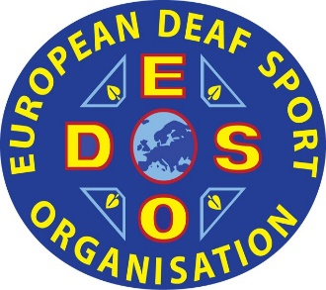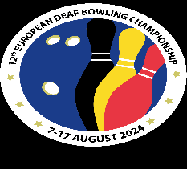
EC Bowling 2024

7-17 august 2024 in Wemmel, Belgium

REGISTRATION BY NAMES AND PHOTOS FOR OFFICIALS
For accreditation
DEADLINE: 5 June 2024
COUNTRY: ____________________

Please type by this document and return by email to EDSO SD Bowling Annette Rundgren, bowling@edso.eu
OFFICIALS (7):
N° | PHOTO | FAMILY NAME | FIRST NAME | FUNCTION  (Coach, Ass. Coach,  Physiotherapist, Masseur, Doctor, Interpreter, Delegate)
1 |  | ___________________________________ | ___________________________ | ______________________________
2 |  | ___________________________________ | ___________________________ | ______________________________
3 |  | ___________________________________ | ___________________________ | ______________________________

N° | PHOTO | FAMILY NAME | FIRST NAME | FUNCTION  (Coach, Ass. Coach,  Physiotherapist, Masseur, Doctor, Delegate)
4 |  | ___________________________________ | ___________________________ | ______________________________
5 |  | ___________________________________ | ___________________________ | ______________________________
6 |  | ___________________________________ | ___________________________ | ______________________________
7 |  | ___________________________________ | ___________________________ | ______________________________

Date (dd/mm/yyyy)

President (Name and signed) | Secretary (Name and signed)

Stamps Federation

