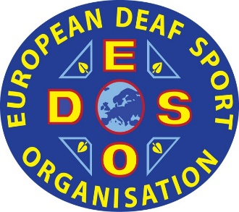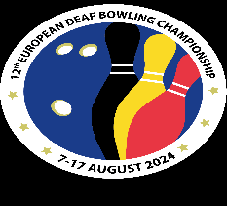
EC Bowling 2024

7-17 august 2024 in Wemmel, Belgium

REGISTRATION BY NAMES AND PHOTOS FOR PLAYERS
For accreditation
DEADLINE: 5 june 2024
COUNTRY: ____________________
Men
Women

Please type by this document and return by email to EDSO SD Bowling Annette Rundgren, bowling@edso.eu

N° |  | PHOTO | FAMILY NAME | FIRST NAME | NATIONALITY
1 |  |  | __________________ | ________________ | ____________
2 |  |  | __________________ | ________________ | ____________
3 |  |  | __________________ | ________________ | ____________
4 |  |  | __________________ | ________________ | ____________
5 |  |  | __________________ | ________________ | ____________
6 |  |  | __________________ | ________________ | ___________

Date (dd/mm/yyyy)

President (Name and signed) | Secretary (Name and signed)

Stamps Federations

