 Ball registration 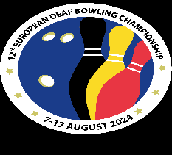

Prefill one issue of this form for each player before your departure (only the white fields). By the conclusion of the official practice, please type a maximum of 6 crosses (X) in the field “In use” for those balls you want to use during the championships.

Name of the player
Country
Bowling with: One hand ( ) or Two hands ( )

In use | Ball name | Serial number | In list | Visual check

The ball check was done by:

