 | 12th  EUROPEAN DEAF SWIMMING CHAMPIONSHIPS  02 July – 07 July 2018  LUBLIN / Poland |  | 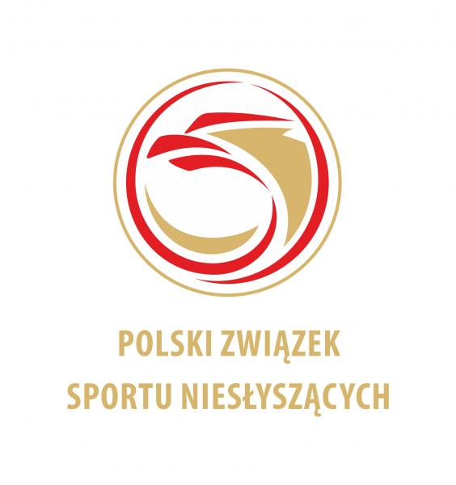
HOTEL RESERVATION FORM
COUNTRY
NAME OF THE FEDERATION
DATE OF ARRIVAL
DATE OF DEPARTURE
NUMBER OF PEOPLE

FEE INCLUDES
Full board accommodation (Breakfast, Lunch and Dinner)
Transportation (airport, station, halls, training, hotel)
Accreditation
Waters
T-shirt
Closing banquet

No of persons | No of nights | Price per person | Total
 |  | 65 Euro

RESERVATION CONTACT:
POLISH DEAF SPORTS ASSOCIATION
Adres: Al. Piłsudskiego 22, 20–011 LUBLIN
POLAND
E-mail: info@pzsn.pl

BANK
Bank Name: Bank Pekao SA III/o Lublin
Swift Code: PKOPPLPW
IBAN: PL 49 1240 2382 1111 0010 4858 8552

Please send this form by e-mail to info@pzsn.pl but not later than 01 April 2018
Date: | President:

