 | 11th EUROPEAN DEAF ATHLETICS CHAMPIONSHIPS  5th EUROPEAN DEAF ATHLETICS JUNIOR CHAMPIONSHIPS  21 August – 26 August 2023  SZCZECIN, Poland | 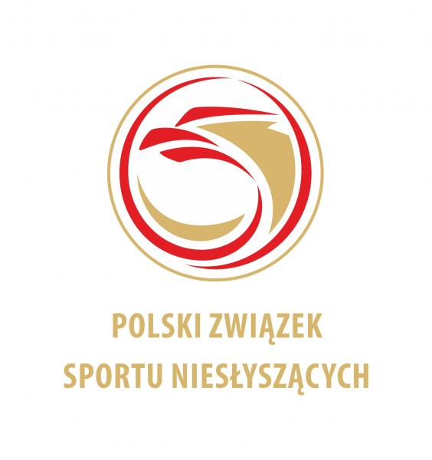
HOTEL RESERVATION FORM

COUNTRY
NAME OF FEDERATION
DATE OF ARRIVAL
DATE OF DEPARTURE
NUMBER OF PERSON
CONTACT PERSON
E-MAIL ADRESS

FEE INCLUDES
Full board accommodation (Breakfast, Lunch and Dinner)
Transportation (training, hotel)
Closing banquet

Type of hotel  Type of room | Number  of person | Number  of nights | Price person | Total
Single Room |  |  | 150 € - fullboard
Double Room |  |  | 130 € - fullboard
Total

RESERVATION CONTACT:
POLISH DEAF SPORTS ASSOCIATION
Address: Al. Piłsudskiego 22, 20–011 LUBLIN
E-mail: info@pzsn.pl
BANK
Bank Name: Bank Pekao SA III/o Lublin
Swift Code: PKOPPLPWXXX
IBAN: PL 65 1240 2382 1111 0010 8917 1900

Please send this form by e-mail to lekkoatletyka@pzsn.pl but not later than 20 July 2023
Date: | President or Secretary:

