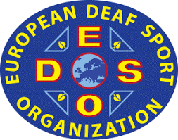 | 3rd EUROPEAN DEAF CURLING CHAMPIONSHIPS  22 November – 27 November 2021  ŁÓDŹ, Poland | 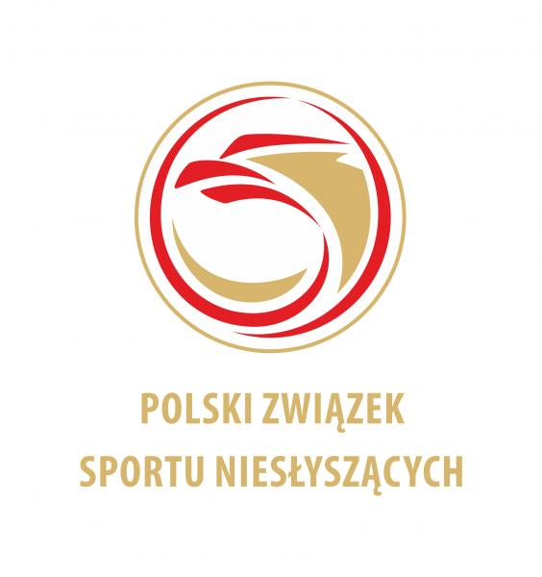
TRAVEL INFORMATION

COUNTRY
NAME OF FEDERATION
NUMBER OF PERSON
CONTACT PERSON
EMAIL ADRES

ARRIVAL
TO WARSAW AIRPORT
DATE | TIME | AIRLINE | FLIGHT NUMBER

BUS or TRAIN
DATE | TIME

DEPARTURE
FROM WARSAW AIRPORT
DATE | TIME | AIRLINE | FLIGHT NUMBER

BUS or TRAIN
DATE | TIME

Comments:
What's the problem then please write

Please send this form by e-mail to info@pzsn.pl but not later than 22 October 2021
Date: | President or Secretary:

