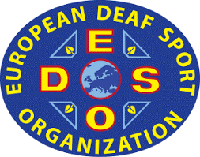 | 3rd EUROPEAN DEAF CURLING CHAMPIONSHIPS  22 November – 28 November 2021  ŁÓDŹ, Poland | 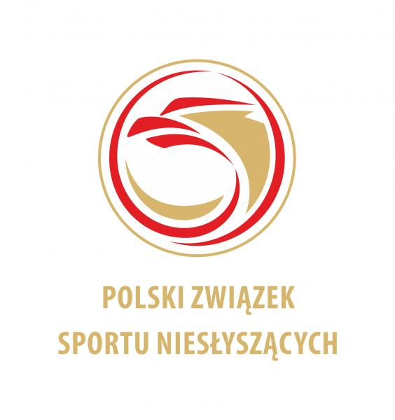
HOTEL RESERVATION FORM

COUNTRY
NAME OF FEDERATION
NUMBER OF PERSON
CONTACT PERSON
EMAIL ADRES

FEE INCLUDES
Full board accommodation (Breakfast, Lunch and Dinner)
Transportation (airport, halls, training, hotel)
Closing banquet

Type of hotel  Type of room | Number  of person | Number  of nights | Price person | Total
Single Room |  |  | 110 €
Double Room |  |  | 90 €
Total

RESERVATION CONTACT:
POLISH DEAF SPORTS ASSOCIATION
Address: Al. Piłsudskiego 22, 20–011 LUBLIN
POLAND
E-mail: info@pzsn.pl

BANK
Bank Name: Bank Pekao SA III/o Lublin
Swift Code: PKOPPLPW
IBAN: PL 65 1240 2382 1111 0010 8917 1900

Please send this form by e-mail to info@pzsn.pl but not later than 22 October 2021
Date: | President:

